**CE Web Site Hosting Server Connection**

**Connect to Arvixe Web Hosting Site for Content Update**

1. Download FileZilla from this site: <https://filezilla-project.org/> . This tool the most popular FTP tool out there. It is free and works great. Many web hosting site supports it.

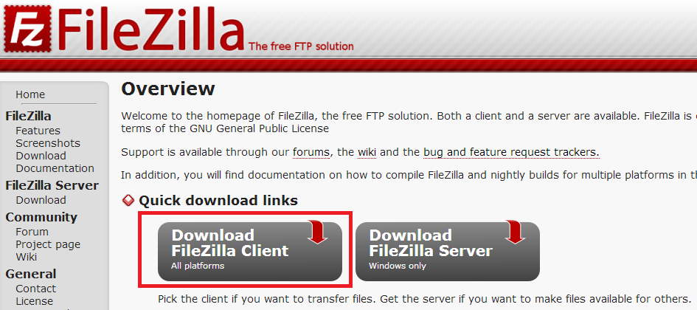

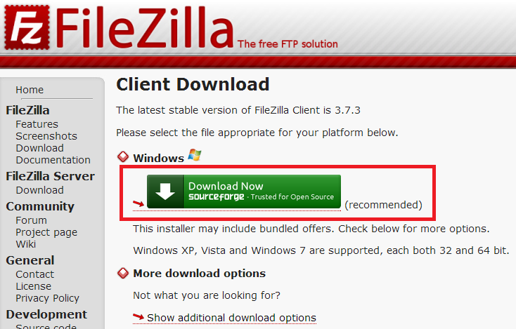

1. Once downloaded, run the FillZilla FTP tool. This tool allows drag-and-drop operation for one or more files and folders. So it is very handy. Currently I have setup only one account as shown below. I will add more accounts in the next few days for content authors.

The host name is **snare.arvixe.com**

The user name is **your first name followed by your last name with no space (SandyTeng, YvetteLee, KathyChen, RobertTung, TRFu, AnthonyChen)**

The password is **Bellevue2013**

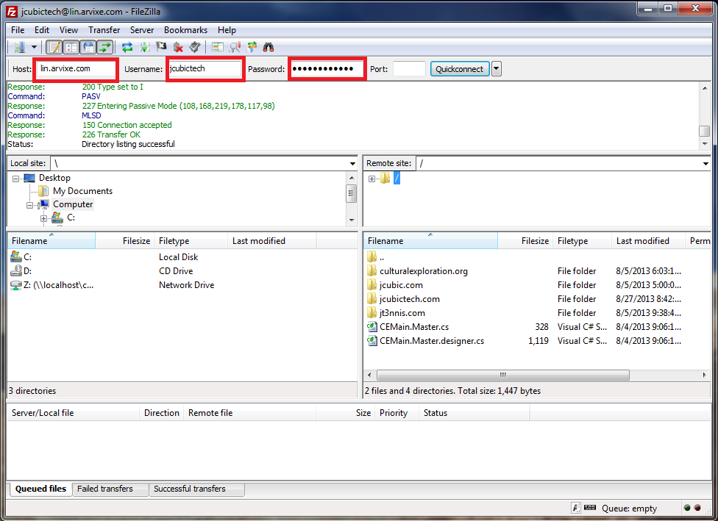

1. Expand the *Remote Site* pane (the top right pane) to see current CE site files. The left side panes are your local file system. You can then use drag-and-drop to move files and folders from your local file system to remote site file system.

